
Governors Monitoring Visit - 2020/2021

Focus Monitoring Area: Early Years

Name of Governor: Hilary Paskins/Katy Wenham
Names of Staff and Student Council member (if applicable): Lucy Newton
Date of Visit: 26/11/20 via Zoom

Focus Area for this visit: Impact of Covid, curriculum changes
Reference to School Interim Growth Plan priorities:
Priority 1: curriculum changes to support all children to make progress
Documents looked at to prepare for this visit:
School Interim Growth Plan, 19/20 monitoring visit report

Follow up points from last monitoring visit:
Nursery Improvement Plan, focus on reading, changes to curriculum to improve progress

Initial Planned Questions for this visit:
Covid has impacted SEN support, MF has said that teachers are picking up the shortfall, how are nursery staff and children coping with this?
Have the curriculum changes helped with progress despite the disruption caused by Covid?
How do you feel parent engagement and connection went through lockdown?

Findings and Evidence seen:

Nursery is a lovely happy place at the moment, but the Reception bubble is currently in quarantine, which includes all staff and children. This has impacted Breakfast Club, which is also closed, and nursery are down a staff member. MF and LN initially checked in on all staff, and are now checking in every day and asking middle leaders to check in on their teams.

Remote learning is being provided and consists of Maths and Literacy input every day and a couple of theme things every week. This is delivered via Tapestry to which most families have access. Three families do not have access to it, so the school keep contact via phone with them. Tapestry allows for good communication with parents, and those who came into Reception from the Nursery are already used to it. The online provision is a mix of teacher videos and other videos from Open Academy.

One potential difficulty could be getting work back to keep track of what the children are doing. There is an option to send it in via email, and teachers will then ring those who do not send things in, and making sure work is getting done. However, school are trying to find a balance to not seem to be nagging. Most parents were completely understanding with the isolation situation, just one that was not impressed. LN is conscious that it will be hard to bring non isolating children especially Nursery children, so there will inevitably be an impact on attendance.

It was great to see LN on the playground yesterday with other senior staff to reassure parents and children. LN agreed that it really feels like the team is pulling together with everyone supporting each other.

Progress

There was no end of year data so not much to measure progress on, though last year’s Reception were a great cohort so will hopefully cope well with missing half the year due to lockdown.

This year’s baseline for the new intake of 70 children (attached at the end of this report) was lower than in previous years, which was to be expected due to the cohort missing so much of the preschool year. The school intended to sign up to the pilot baseline scheme but would have had to wait until autumn to get results. This was felt to be too late as the school wanted to be able to target areas in need of progress from the start of the school year. Nor did the school have recent accurate information from preschool records, and they were unable to do home visits which usually provide a lot of information about a child’s progress level. LN devised a baseline instead which was stringent and included a S&L baseline done over first few weeks. This provided the necessary information for teachers to be able to make the learning as effective as possible from as early in the term as possible. LN wants to moderate with other schools in future. When the children are assessed against development markers they will be treated as cohort rather than looking at individual ages. Unfortunately, the Reception bubble had to close mid assessment point 2, so this will continue when they return to get that progress snapshot.

Curriculum

Curriculum will be completely tailored to areas where progress is needed. Teachers have hit the ground running, and children are ready for it, have missed the routine.

SEN

There are 3 children with an EHCP in Reception, one in each of the classes. One is medical as the child is diabetic with poor attendance currently as their blood sugar levels go up and down quickly. The other 2 are for children with attachment disorders, one of whom would benefit from attending Milestones next year.

Impact of Lockdown

The impact of lockdown is huge. The cohort is quite needy and less independent than previously, they have had fewer opportunities to develop language skills, and their movement and handling ability is lower. Reading is low as they have missed a huge chunk of nursery. The hope is that even though they are low now it might be because the children are not so well known by staff so hopefully will be higher by end of year (49 of the Reception cohort have come from our nursery). In terms of mental wellbeing staff flag up any issues with the children and LN checks it is not anxiety.

Another impact has been that parents have not been able to come into the classrooms and cannot make links with each other. The school hopes to do as many parent events as possible at Easter, Covid allowing, to allow parents to meet each other.

Among the Nursery children, LN feels the new intake are being let down by system as health visitors are not following up concerns. This means LN has to provide a lot of support to staff to get the children reception ready. The new cohort are poor attenders too, with lower numbers due to being unable to offer settling sessions with parents. Children from last year are doing brilliantly, with just a handful struggling with tiredness. The Nursery is completely free flow this year which means it feels more like a team approach. Steff is doing a brilliant job, modelling to all staff resulting in a positive impact. Free flow also means older children want to help the younger ones, the children learn from each other, and older ones are provided with opportunities to take responsibility. Each child still has a key worker, with specified key worker time.

LN is putting together a case to present to the council to get them to bump up the money for nursery places. A lot of children are due to start in January, in the meantime, some parents have deferred starting or not returned children and some parents want to keep the space but not send the child. The council have said that the school can still claim for those children.

For hygiene, children use hand sanitiser, items used are cleaned regularly, the number of toys has been reduced and are rotated regularly.

For the 2021 Reception intake, school has been unable to do open mornings but has done a virtual visit online, hosting 3 open meetings at different times throughout the day. There was not a big uptake but those who attended really appreciated it. Anyone with queries can contact LN direct. The school is still looking at getting the numbers up. LN will put a specific EY page on the website to make information accessible to prospective families.

Evidence of Christian Distinctiveness:

The Nursery and Reception have been thinking about the school vision this term. Here are the Nursery’s thoughts:

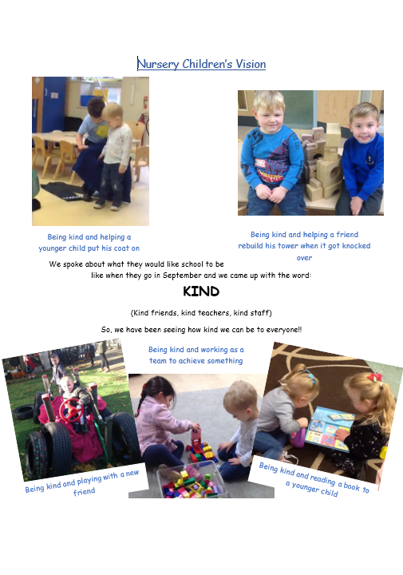

Questions/follow-up points for discussion with headteacher and for future visits:
Wellbeing following second lockdown

Date for next visits:
Summer term 2021

Reception 2020 Baseline
Children | Autumn  born | Spring  born | Summer  born | Boys | Girls | EAL | SEN | EHCP | Pupil  premium
82 | 29 | 23 | 30 | 41 | 41 | 7 | 5 | 4 | 22

 | Well below ARE |  | Below ARE |  | ARE |  | Above ARE
Specific areas in month age bands % | 2019 | 2020 | 2019 | 2020 | 2019 | 2020 | 2019 | 2020
EYFS Reading | 27 | 43 | 42 | 44 | 25 | 11 | 1 | 0
EYFS Writing | 23 | 24 | 32 | 38 | 40 | 34 | 1 | 0
EYFS Numbers | 22 | 29 | 21 | 45 | 51 | 18 | 3 | 4
EYFS Shape/ Space & measures | 15 | 22 | 19 | 45 | 62 | 30 | 0 | 0

Prime areas in month age bands % | 2019 | 2020 | 2019 | 2020 | 2019 | 2020 | 2019 | 2020
EYFS Making Relationships | 29 | 33 | 21 | 29 | 47 | 35 | 0 | 0
EYFS Self confidence | 23 | 26 | 16 | 37 | 56 | 35 | 0 | 0
EYFS Managing feelings & behaviour | 22 | 27 | 29 | 35 | 45 | 35 | 0 | 0
EYFS Moving & handling | 35 | 35 | 37 | 39 | 34 | 23 | 0 | 0
EYFS Health & self-care | 10 | 12 | 21 | 11 | 66 | 74 | 0 | 0
EYFS Listening & attention | 21 | 32 | 30 | 40 | 45 | 26 | 0 | 0
EYFS Understanding | 18 | 34 | 29 | 37 | 49 | 27 | 0 | 0
EYFS Speaking | 25 | 41 | 37 | 29 | 34 | 27 | 0 | 0

Specific areas in month age bands % | 2019 | 2020 | 2019 | 2020 | 2019 | 2020 | 2019 | 2020
EYFS People & communities | 26 | 51 | 36 | 39 | 34 | 7 | 0 | 0
EYFS The World | 23 | 45 | 49 | 41 | 23 | 11 | 0 | 0
EYFS Technology | 3 | 6 | 11 | 32 | 82 | 60 | 0 | 0
EYFS Exploring using media | 22 | 34 | 45 | 43 | 29 | 20 | 0 | 0
EYFS Being imaginative | 16 | 35 | 45 | 46 | 34 | 15 | 0 | 0

The baseline assessments were devised by EY’s Lead and SALT, these were then shared with teachers. The Baseline judgements are completed by Reception class teachers, taking pre-school records into account and making a judgement on what the team has observed in the first few weeks of the school year. This year has been particularly challenging as most of the pre-school records received were only up to March 2020 due to COVID closures. We have therefore assessed the children based upon our own activities, in depth conversations with nursery staff and a ‘gut’ feeling of where children are developmentally as a best fit.
The government baseline test was due to come into effect this year but has been postponed due to COVID. We completed our own assessments to ascertain early number and literacy skills.
The age expectation at baseline is that children should be working within the high 30-50 month or low 40-60 month development band (green). Any children working 40-60mid or above are exceeding expectations (blue). Any children working 30-50 mid are working just below the age expected (orange). And any children working below this are considered to be working well below age expected development.
We have quite an equal split between Autumn, Spring & Summer born children and exactly half are boys.
All areas have a higher proportion of children working below age related expectations in comparison to September 2019. We believe this is due to limited access to nursery provision in the Summer term 2019, also because of the changes we made to transitions and the children not being as familiar with the setting & adults.
Our 3 areas of the biggest concern are; Reading, The World and People & the communities – the latter two have been especially difficult to assess at this time and our themes and curriculum will be designed to develop these areas. We are seeing progress in reading already and our phonic programme is designed as such that the children will be taught phase 2 by the end of the Autumn term.
Generally, we feel the children have settled brilliantly (all things considered), they have adapted very quickly to the routines and boundaries set by the class teachers. Some children are finding the formality of the day difficult, again I think this is because they missed the later stages of pre-school where it begins to become more formal.
Speech and language remains a concern across all 3 classes & the SALT support and advice has been invaluable.

